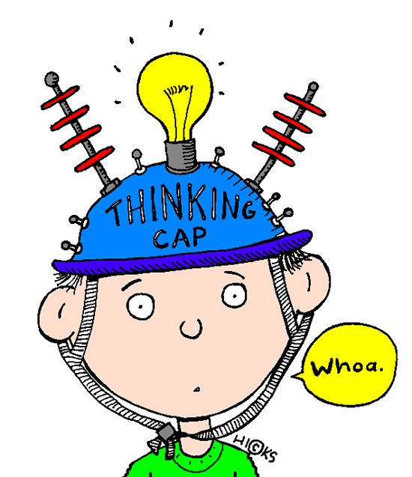
Comprehension in the Early Grades
What is it?
Simply put, comprehension is the reader's ability to understand what he is reading.
Why is it important?
Comprehension is the main goal of reading. The written word is an author's way of communicating with a reader. A reader needs to be able to understand what the author is saying and think about how the author's words affect him. Good comprehension leads to reading enjoyment. Reading enjoyment leads to more time spent reading. More time spent reading leads to better comprehension, and so on...
What can we do at home?
Sequencing errands - Talk about errands that you will run today. Use sequencing words (sequence, first, next, last, finally, beginning, middle, end) when describing your trip. For example, you might say, "We are going to make three stops. First, we will go to the gas station. Next, we will go to the bank. Finally, we will go to the grocery store."
Sequencing comics - Choose a comic strip from the Sunday paper. Cut out each square and mix the squares up. Have your child put them in order and describe what is happening. Encourage your child to use words like first, second, next, finally, etc.
Every day comprehension - Ask your child the five Ws and an H questions (who, what, when, where, why, how) about an event in his day. For example, if your child attended a party, you could ask, "Who was there? What did you do? When did you have cake? Where did you go? Why did the invitation have dogs on it? How did the birthday child like the presents?" Once your child is comfortable answering these questions about his experiences, try asking these questions about a book you've read together.
Think aloud - When you read aloud to your child, talk about what you are thinking. It is your opportunity to show your child that reading is a lot more than just figuring out the words. Describe how you feel about what's going on in the book, what you think will happen next, or what you thought about a character's choice.
Reading fiction
1. Before reading - Point out the title and author. Look at the picture on the cover and ask, "What do you think is going to happen in this story? Why?" This will help your child set purpose for reading.
2. During reading - Stop every now and then to ask your child to tell you what has happened so far or what he predicts will happen. You might also ask for your child's opinion. "Do you think the character did the right thing? How do you feel about his choice?" Explain any unfamiliar words.
3. After reading - Ask your child to retell the story from the beginning, and ask for opinions, too. "What was your favorite part? Would you recommend this to a friend?"
Reading Nonfiction
1. Before reading - Point out the title and author. Look at the picture on the cover and ask, "What do you think you'll learn about in this book? Why?" This helps your child consider what he already knows about the topic. Look at the table of contents. You and your child may choose to read the book cover to cover or go directly to a certain chapter.
2. During reading - Don't forget the captions, headings, sidebars, or any other information on the page. Young readers tend to overlook these, so it's a good idea to show that the author includes lots of information in these "extras".
3. After reading - Ask your child, "What was it mostly about? What do you still want to know? Where could you find out?"
PS - Don't let a cozy reading time turn into an interrogation! Keep the conversation low-key.

