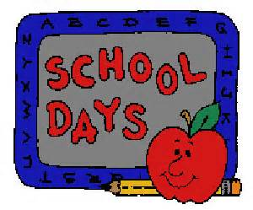
August 15, 2014

Dear Second Grader and Family,

Welcome to another exciting school year! As summer comes to a rapid end, I wanted to take an opportunity to welcome you to second grade. I am really excited about this years’ class! When you return to school on September 2nd, I know you will be as thrilled as I am to see many familiar faces and welcome opportunities to make new friends. We are going to be learning so many new and interesting things this year.

The first day of school is quickly approaching. We will be taking time on that first day to organize our belongings and sort through the items on the supply list, so please bring in what you are able to. There is an updated supply list on the back of this letter and there is also one on our school website.

Students may bring in a snack to eat during our snack time. Healthy snacks are preferred, and candy should not be brought to school. Water bottles may be kept at desks, and those with sports- tops are recommended. Students may not trade or share snacks. **Remember: Our classroom is nut-free! Transitioning from summer days to a full day at school will take some time, and one of the challenges includes eating on a schedule, so make sure to bring a snack.

More information about second grade will be sent home for your families on the first day of school. Hopefully I will meet many of you at our Meet the Teacher Open House on August 27th. Otherwise, I’ll see you on the first day of school! If you have any questions about the suggested school supplies, or anything else, please feel free to email me at Laura.gavin@farmington.k12.mi.us .

Enjoy the rest of your summer and I will see you very soon!
Fondly,
Mrs. Gavin

Upcoming Dates

Meet the Teacher Open House--August 27th from 3:30-4:30 pm
First day of school—September 2nd
Curriculum Night—(K-2) September 10th from 6:30-7:30 p.m.

